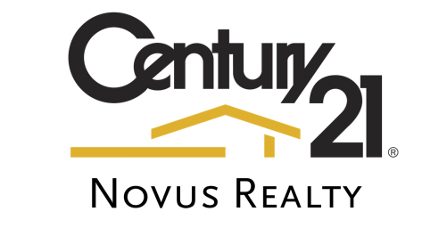
Duffey Commercial Leasing & Management, LLC
dba Century 21 Novus Realty

Direct Deposit Agreement Form

Authorization Agreement

I hereby authorize Duffey Commercial Leasing & Management, LLC dba Century 21 Novus Realty to initiate automatic deposits to my account at the financial institution named below. I also authorize Century 21 Novus Realty to make withdrawals from this account in the event that a credit entry is made in error.
Further, I agree not to hold Century 21 Novus Realty responsible for any delay or loss of funds due to incorrect or incomplete information supplied by me or by my financial institution or due to an error on the part of my financial institution in depositing funds to my account.

This agreement will remain in effect until Century 21 Novus Realty receives a written notice of cancellation from me or my financial institution, or until I submit a new direct deposit form.

Account Information

Name of Account Holder:
Address of Account Holder:
Name of Financial Institution:
Routing Number:
Account Number: ☐Checking □Savings

Signature

Authorized Signature (Primary): Date:
Authorized Signature (Joint): Date:
Please attach a voided check or deposit slip and return this form to the Payroll Department.

